Chapter 1. Background and State of the Art.
This Chapter is organized into two principal segments. The first part conceptualizes the relevant technical terminology and situates it within a historical development perspective. While it does cover the whole technological developments, it provides an overview of the Digital Humanities within a broader panorama and defines the significant standards used throughout this study. The second part discusses existing conceptual models and Digital Humanities projects on Cultural Heritage. It analyzes their development and provides a comparative assessment of their commonalities and methodological divergences with this study.

  - Digital Humanities Background: Terminologies and definitions
At the beginning of the World Wide Web, the digitization of physical objects into the digital environment, through transcription or imagery, paved the way for a network that eliminated the need for physical media to access and consume them. Initially, possessing a digital copy of a document already represented a significant step toward the digitization of collections and procedures that once accumulated in paper archives. The development of the Web also led to increasing complexity in virtual processes: the need to establish protocols, ensure interoperability standards, and pursue greater automation changed the very conception of what it means to be digital. The emergence of “digitalization” concept, distinct from earlier “digitization”, illustrates this growing complexity.
Brennen and Kreiss (2016) present digitization as “the material process of converting analog streams of information into digital bits”. However, the authors argue that a resource only becomes functionally digital through digitalization, as “the way many domains are restructured around digital communication and media infrastructures.” (Brennen and Kreiss, 2016). In this view, digitization is a technical prerequisite, whereas digitalization is the transformative process that actualizes a digital state and makes it functional to digital operations.
The field of Digital Humanities, as part of this extensive digital transformation, also evolved from this reorientation. DH is defined not only by the digitization of cultural artifacts but also by the application of computational methods to organize, store, analyze, and visualize humanistic knowledge. In this context, Berry (2011) observes that computational techniques “not only […] introduce new methods, which tend to focus on the identification of novel patterns in data as against the principle of narrative and understanding, they also allow the modularisation and recombination of disciplines within the university itself” (Berry 2011).
The Semantic Web is defined as an extension of the World Wide Web where its content is interpretable by machines, a “Web content that is meaningful to computers” (Berners-Lee et al., 2001). The introduced approach to data utility and storage proposes an alternative to the web architecture based on files and directories, in which documents are linked to one another via hyperlinks. It was formally introduced to the public in 2001 by Tim Berners-Lee, James Hendler, and Ora Lassila. Noticeably, Berners-Lee, the creator of WWW, HTTP, HTML, and URI protocols, also founded the World Wide Web Consortium (W3C), an international organization that develops and oversees web standards, many of which were applied in this study.
A semantic transition, however, requires an underlying transformation. To be automated, argue Berners-Lee et al. (2001), knowledge must have a specific formal representation, distinct from the traditional centralization of data in static databases. Instead, data must be stored in logical and distributed structures that allow for automated induction and deduction, “reasoning,” without direct human mediation (Berners-Lee et al., 2001). This new approach changes the way knowledge is organized and represented in the virtual environment.
The technologies required for this paradigm shift already existed at the time: the eXtensible Markup Language (XML) and the Resource Description Framework (RDF). The former was already used to create data structures, in this case, syntaxes or serialization formats, while the latter standardized the representation of semantic meaning. RDF employs a subject–predicate–object triple structure to describe relationships. These relationships connect into knowledge graphs that are both meaningful to humans and readable by machines.
Berners-Lee (2006) introduces Linked Open Data (LOD), an infrastructure that supports RDF graphs from open-licensed databases interlinked across distributed networks via Web protocols. LOD uses persistent Uniform Resource Identifiers (URI) both to identify things (such as people, places, or concepts) and to trace machine-readable descriptions (Berners, 2006). When machines perform HTTP GET requests on these URIs, they receive RDF data, triples that can be parsed, queried, and linked across datasets. Notably, this infrastructure also enables proprietary counterparts that apply the same principles within closed commercial systems.​
The evolution of data querying is another transformative advancement on the LOD. The U.S. National Information Standards Organization (NISO) states that, before the RDF triple approach, search engines relied primarily on keyword and string matching, and, in the case of searches within relational databases, data were treated as records in tables, loaded in batches through custom processes or entered manually (Riley, 2017). The use of the SPARQL Protocol and RDF Query Language (SPARQL), a query language for retrieving information from RDF graphs, using the subject–predicate–object triple structure, creates a new form of data processing, as semantic filters can exclude undesired meanings of a searched term (Scherp et al., 2024), moving from static data storage to a web of interlinked, queryable data.
The final requirement for the Semantic Web is the use of structured data supported by standardized terms and clearly defined datasets. In other words, it involves categorizing the semantic complexity of natural language into conceptual contexts, the domains, where the connotations and denotations of terms are explicitly defined for machine interpretation. These structured conceptual frameworks are the ontologies.
It is essential to adhere to the definition of "ontology" within the Web context, as the term carries differing connotations across many scientific fields. Studer et al. (1998) define an ontology as a "formal, explicit specification of a shared conceptualization." (Studer et al., 1998). In this sense, “formal” refers to a defined structure for machine readability; “specification” denotes the explicit mapping of the domain and its logical relations; and “shared conceptualization” implies a consensual definition of knowledge that accounts for the non-universal meanings of terminologies.
At first glance, the ontology definition may suggest that ontologies are closed systems, coherent only within their own internal definitions. Such isolation would be undesirable for a Semantic Web intended to integrate multiple ontologies simultaneously. To prevent the mismatch between them, the necessary integration is facilitated by RDF Schema (RDFS), which provides a language for interoperability, and the Web Ontology Language (OWL). OWL is an RDF-based computational language that provides a framework for relating ontologies across the Web. By enabling inference across domains, OWL serves as a mediator for automated reasoning. As declared in W3C standards, it manages relations such as symmetry, equivalence, intersection, functions, among others; and also provides formal mechanisms for feature deprecation. (W3C 2004; W3C 2012).
In addition to defining ontology within Digital Humanities, it is essential to disambiguate recurrent terms that may appear synonymous, such as metadata description standards and metadata schemas. A metadata description standard comprises a set of formal guidelines and rules regulating how information is documented to facilitate retrieval and sharing (Doerr et al., 2005). While ontologies often follow these standards, the standards themselves can exist independently of the Semantic Web; indeed, many of them were already in use before its implementation.
In contrast, metadata schema is web-native and provides relationships between metadata elements, establishing rules for their use and management, specifically regarding semantics and syntax (ISO 23081-1, 2017). It functions as the structural foundation upon which the relational logic of an ontology is built. Notably, these definitions align with ISO standards, although some authors use the terms indiscriminately.
With the foundational concepts and historical development established, it is essential to examine the current state of the Semantic Web usage after more than two decades of its implementation. Scherp et al. (2024) point out that “using graph data on the Web has become a widespread practice.” (Scherp et al., 2024). This statement is validated by the consistent growth of the LOD Cloud, as presented in the Figure 1, across both private and public sectors, supported by industry giants such as Bing, Google, and Yandex, using standardized formats like JSON-LD, as well as governmental institutions such as the European Commission, U.S. and U.K. governmental agencies websites, which provide statistical and transparency data in RDF format with SPARQL query endpoints or REST APIs. (Scherp et al., 2024).
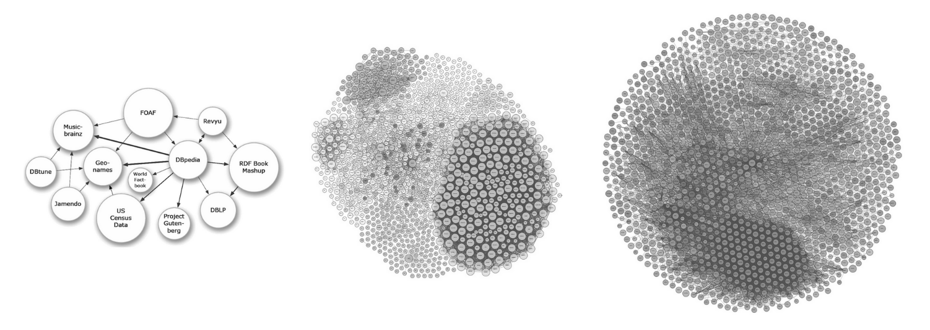
2007 2014 2026
Figure 1. Growth of the LOD Cloud, 2007–2026.
Source: LOD Cloud Draw, 2026.

Another significant outcome of Linked Data development, as Scherp et al. (2024) describe, is the convergence with adjacent fields, particularly Natural Language Processing (NLP), including Large Language Models (LLMs) and machine-learning approaches. Although current LLMs are not trained solely on Linked Open Data, their performance improves with the degree of Web indexation and the availability of reliable structured semantical data. In this context, the evolution of current AI systems, particularly generative AI, increasingly aligns with a semantic data environment that provides the structure and context necessary for advanced forms of reasoning. This convergence represents a critical frontier, as the reliability of institutional databases in RDF ensures the verifiability of knowledge required for scholarly rigor, while current LLMs still suffer from limitations stemming from their non-specific corpora and algorithmic hallucinations.
An example of this convergence effort is ATR4CH methodology (Adaptive Text-to-RDF for Cultural Heritage), a framework designed to handle Cultural Heritage domain-specific vocabularies and identify implicit relationships that would be missed by keyword or rule-based systems (Schimmenti et al., 2026). By coordinating LLM extraction with ontological frameworks, this approach treats the LLM as the primary engine for identifying contextual patterns within textual corpora. The relationship is operationalized through a pipeline architecture that decomposes Knowledge Graph generation into manageable subsets, each mapped to a specific JSON schema that serves as an intermediary between the natural language of the LLM and the formal triples of the RDF graph.

In other side, some authors claim that Semantic Web adoption has fallen far short of initial expectations. Most web pages still rely predominantly on pre-Semantic Web protocols (Hendler, 2013). Hogan (2020) identifies several critiques that explain this trend: semantics is difficult to understand, invisible to most users, and laborious to add manually to content; moreover, standards are overly verbose. Additionally, Hogan highlights that dependence on reliable publishers, the complexity of ontology axioms and their slow learning curves, and high implementation costs have confined its applications to niche contexts (Hogan, 2020). The author also highlights the importance of converging with other fields; this integration may foster the future widespread adoption of a machine-readable Web, enabling it to fulfill its potential.
In contrast to the general stagnation noted by Hogan, in the field of Cultural Heritage, Linked Open Data was established as a prevailing paradigm. The consistent use of ontologies by institutions such as Europeana, the U.S. Library of Congress, the Getty Research Institute, among many others, has consolidated its adoption across GLAM (galleries, libraries, archives, and museums) sectors and academia, establishing it as a de facto standard for Digital Humanities (Hyvönen, 2022).

1.2 Ontologies and Controlled Vocabularies
While the broader Web had a limited semantic adoption, the Cultural Heritage field began formalizing its conceptual frameworks a decade earlier, addressing the challenges of institutional data exchange. This trajectory began in 1994, when the International Council of Museums (ICOM) established the Documentation Standards Working Group within the International Committee for Documentation (CIDOC) to develop a global resource for research, exchange and advanced querying, taking into account the field's information heterogeneity.
The primary result of this effort was the CIDOC Conceptual Reference Model (hereafter referred to as the CRM). Released in 1999 and subsequently aligned with RDF standards in 2003, the CRM provided the formal logic necessary to integrate distinct datasets. The model was formalized as ISO 21127 in 2006 and updated to the current version in 2023. Since then, CRM has served as the reference model for GLAM institutions and has consequently been widely used in Digital Humanities, as it complies with the FAIR framework (Richards et al., 2022).
The CIDOC CRM is defined as:
A theoretical and practical tool for information integration in the field of cultural heritage … by providing definitions and a formal structure for describing the implicit and explicit concepts and relationships used in cultural heritage documentation … Such models are also known as formal ontologies. These formal descriptions allow the integration of data from multiple sources.
As mentioned above, the FAIR framework is a set of good practices in knowledge organization that encompasses four principles: Findability, Accessibility, Interoperability, and Reusability, for both humans and computers. This approach is fundamental for the Digital Humanities, as alignment with these principles ensures the long-term viability and utility of data. Furthermore, it moderates machine action in an environment where data volume, complexity, and creation velocity are increasing (Wilkinson et al, 2016).
To understand the methodological choices presented in this study (Chapter 3 Methodology), it is necessary to examine the CRM's concepts and formal structure. All definitions and declarations herein are based on the CRM version 7.1.3, released in February 2024. This version updates the model by refining, deprecating, and removing certain previously used classes and properties.
The CRM is a formal, logical system designed to organize Cultural Heritage data, providing 81 classes and 160 properties for relational descriptions. Classes represent types of cultural heritage entities, such as “Actor (E39)”, “Activity (E7)”, “Event (E5)”, and “Period (E4)”. These classes are semantically connected via properties, which define relationships such as "has type (P2)," "has time-span (P4)," or "took place at (P7)" (see Figure 2).
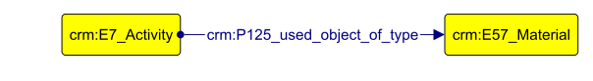
Figure 2. Example of a formal CRM relation.

Although the model offers an extensive vocabulary, entities cannot be related in arbitrary ways; they must obey a strict inheritance hierarchy and defined domain and range restrictions (axioms). The valid relationships between entities are declared in the official CRM documentation, ensuring that the resulting data remains interoperable across different institutional repositories and sources.
The CRM features many complementary models, such as CRMgeo (a spatiotemporal model), CRMdig (for provenance metadata), CRMArcheo (for archaeological management), and CRMtex (for the study of ancient texts), among others. One of the most widely used extensions is FRBRoo (Functional Requirements for Bibliographic Records, object-oriented), currently updated as LRMoo (Library Reference Model, object-oriented), tailored for bibliographic data in Cultural Heritage contexts as libraries and archives. Although LRMoo supports complex archival modeling, this study utilizes the Dublin Core vocabulary to manage publication metadata.
The former Dublin Core Metadata Element Set (DCMES), later extended as the Dublin Core Metadata Initiative Terms (DCMI), hereafter referred to as DC and DC Terms respectively, provides a lightweight metadata description standard for bibliographic and other resources. Primarily with 15 broad descriptive elements, DC was later expanded into DC Terms, which includes 55 properties and 22 classes, and refined into a formally defined RDF structure.​ Compared to LMRoo's hierarchical and highly structured model, DC is simpler and less rigid, making it widely used for scholarly article indexing in digital repositories and web-based contexts. (DCMI 2026)
The bibliographical datasets used in this study include properties derived from the fifteen primary elements of Dublin Core: Title, Subject, Description, Source, Language, Relation, Coverage, Creator, Publisher, Contributor, Rights, Date, Type, Format, and Identifier.
The Bibliographic Ontology (BIBO), a specialized ontology for documentation and citation, complements this approach by providing additional, domain-specific classes. Another supporting ontology employed is Friend of a Friend (FOAF), which provides more objective representations of human relationships than equivalent representations in CRM, as the latter would require a granular conceptualization to satisfy the ontology's formal axioms.
Beyond ontology, an essential feature of LOD that facilitates data integration is the use of authorities or controlled vocabularies. Controlled vocabulary constitutes a catalog of standardized set of terms, names, or identifiers designed to ensure consistency in the description and retrieval of information via a persistent URI (Harpring, 2010). Controlled vocabularies distinguish entities sharing identical nomenclature (homographs) and unify references to entities known by multiple names, either due to language and translation differences or to the use of synonyms, generic terms, or lexical variations (Harping, 2010). The authorities employed in this study are the Virtual International Authority File (VIAF) for personal and corporate names, BDpedia for supplementary data filling gaps in other authorities, the Digital Object Identifier (DOI), a permanent identifier performing function of authority for publications, the Open Researcher and Contributor ID (ORCID) for researchers’ identification, and GeoNames for toponymic nomenclature.
Additionally, the Simple Knowledge Organization System (SKOS) serves as a controlled vocabulary model, functioning as a classification framework for thesauri, taxonomies, and similar classification schemes. It provides semantic structure for concept mapping and disambiguation, ensuring that relationships between conceptual entities are explicitly defined and preventing these concepts from becoming machine non-iterable character strings (W3C, 2009). It is important to note that SKOS does not provide the vocabulary itself, but rather the structural model that other agents, such as UNESCO, use to render their concepts semantically meaningful. The aforementioned thesauri, on the other hand, constitute curated sets of specific concepts and their definitions, as glossaries, which can be encoded using SKOS to support consistent description, retrieval, and interoperability. This study utilizes vocabularies from Getty Art & Architecture Thesaurus (AAT) and UNESCO Thesaurus.

1.3 The State of the Art
During the preparation of this study, no specific Khmer heritage LOD projects with public SPARQL endpoints were identified in the LOD Cloud (lod-cloud.net, accessed February 2026) or via targeted searches on Google Scholar and data catalogues. Other DH initiatives, however, provide functional parameters for applying LOD principles, such as Europeana, Fasti Online and Arches Platform.
Europeana is an exemplary application of DH principles. Often described as a digital library of cultural heritage objects, the platform aggregates material from more than a thousand institutions across the European Union (EU). Concordia (2009) and Doerr (2010) observe that this description captures only a small part of its functionality: rather than functioning as a traditional archive, Europeana exposes an Application Programming Interface (API) that enables semantic operations via Linked Open Data (Concordia, 2009), providing rich contextualization and visualization of object representations that would not be supported by a conventional digital library interface (Doerr, 2010).
In line with shared DH practices, Europeana has developed its own ontology, the Europeana Data Model (EDM), by reusing and integrating preexisting ontologies (Doerr, 2010), with a strong emphasis on the searchability and reusability of data for both human users and automated processes. EDM incorporates, and is a reference base for this project, already mentioned ontologies and controlled vocabularies such as CRM, DC Terms, LRMoo (FRBR), SKOS, FOAF, VIAF, as well as MARC, VRA, and LIDO, other highly employed ontologies and metadata descriptive standards (Doerr, 2010).
Concordia (2009) and Doerr et al. (2010) accurately predicted the transformative impact of the Europeana Data Model (EDM). Since its 2010 implementation, Europeana's successive Strategic Plans (2011–2030) have evolved from content aggregation and standards adoption (notably IIIF) toward operational maturity and leadership in the Common European Data Space for Cultural Heritage, prioritizing AI-ready 3D assets and machine learning datasets, representing the current state of the art in digital cultural heritage management (Europeana Foundation 2011, 2015, 2025).
A critique that emerges from Europeana’s experience with Linked Open Data (LOD) concerns the replicability of its model. While Europeana’s achievements have significantly contributed to establishing LOD as a standard within the Cultural Heritage domain, its success depends on substantial institutional support and funding, particularly from the EU’s Digital Europe Programme (European Commission, 2026). This creates a structural imbalance: institutions outside countries on the digital frontier, such as the United States, China, and Western Europe, often lack both the financial resources, technical expertise, and metadata infrastructure needed to effectively digitalize their collections or implement LOD at scale.
As a methodological note, the structure of one of the data model axes presented in this work, for Museum Collections, is conceptually aligned with Europeana's EDM. Yet, this work adopts a shortened approach, a strategy for high-risk or resource-constrained environments. The model contains considerably fewer metadata elements than EDM. This apparent simplification, addressed in the Methodology Chapter, is a necessary adaptation for Cambodia's historical and political context, which will be discussed in the next chapter. Conversely, when applied to objects with richer contextual information, the model can readily be extended to include more detailed metadata descriptions.
Although Europeana represents a large-scale aggregation model, Fasti Online exemplifies a more decentralized and participatory approach to digital Cultural Heritage management. Fasti Online is an API-based database for archaeological documentation, covering data from 2000 onwards, published by the International Association for Classical Archaeology (AIAC) in partnership with other institutions. Fasti Online provides three sections of reports and metadata: archaeological surveys, conservation projects and excavation projects; and also hosts a peer-reviewed Journal, Fasti Online Documents & Research (Fold&r). The platform encompasses fifteen countries and metadata in fifteen languages (Fasti Online, 2026).
As evaluated by Johnson et al. (2018), the platform was not fully realized within an LOD network. Although designed according to the CRM model (CRMArcheo extension), its pages were accessible only in human-readable HTML and JSON formats. The implementation of a RDF Graph and SPARQL endpoint was conceived as a future step (Johnson et al., 2018) but had not been implemented by the time of this study.
Fasti Online is a good example of a successful DH project, demonstrating the expanding potential of cultural heritage initiatives. Originating in 2000 as an effort to expand a database for archaeological research on the Roman Empire, the project has evolved from featuring only an Excavation section (2003) to later including Conservation (2015) and Survey (2016), covering the area of the Mediterranean and adjacent regions. Using a model of crowd-sourced data synchronization, researchers can upload their own documents without specific data entry standards, though general guidelines are required. These contributions are later collectively reviewed and integrated into the datasets. (Fasti Online, 2026). This flexibility has encouraged the participation of numerous institutions and research partners.
In addition, Fasti Online offers interaction through a Geographic Information System (GIS) integrated with the Mediterranean Archaeology GIS (MAGIS). This georeferencing feature allows users to explore specific points or areas covered by the projects in each section, linking the datasets to their actual spatial context.
Arches Platform provides additional examples of DH projects implemented using Semantic Web technologies based on CRM and related conceptual models. Arches is an open-source data management platform developed by the Getty Conservation Institute and the World Monuments Fund, hosting cultural heritage projects from a wide range of institutional and methodological contexts. Several projects hosted on Arches share common approaches with the present study, as Nepal Heritage Documentation Project, HistoricPlacesLA, and The Soqotra Heritage Database.
The Nepal Heritage Documentation Project (NHDP), developed by Heidelberg University in cooperation with the Department of Archaeology of the Government of Nepal, documents monuments through geolocated data, providing historical context, conservation status, and assessments of potential risks. The platform also includes glossaries and photographic documentation, which can be accessed via a web interface or mobile applications. Additionally, it offers touristic thematic routes focused on selected historical contexts by the user. The database is structured in RDF, enabling advanced search functionalities across its datasets.
The HistoricPlacesLA (HPLA) is an interactive mapping tool developed by the City of Los Angeles from municipal records, presenting a wide range of cultural heritage assets, including architecture, historic neighborhoods, bridges, and landscapes. The project includes numerous classification categories that allow for multiple layers of visualization. It also offers specific search filters, such as architectural styles, zoning categories, and the social groups that shaped the city’s heritage. The platform is based on CRM and allows data export in CSV and shapefile formats.
Lastly, the Soqotra Heritage Database is a project funded through the British Council’s Cultural Protection Fund. It offers a geolocated interface for cultural objects of interest and the biodiversity of Socotra Island and also includes a bibliographic catalog that links publications to their corresponding study locations, although it does not present structured metadata.
Within this landscape, where no specific LOD projects currently address Khmer heritage, the case studies of Europeana, Fasti Online and Arches projects offer valuable examples of practices grounded in LOD principles, though across different scales and methodological approaches. While these models cannot be directly applied due to the historical, archival, and documentary particularities of each set of sources, their CRM-based methodologies can be adapted and reused in other contexts. The present study proposes such adaptations for the modeling of Khmer heritage in LOD, which will be examined in the following chapters.
This study develops a data model that represents the initial stage of a Linked Open Data project. The study arises from the question of how applicable current standards are in diverse contexts, such as on Cambodia’s reality, and from the desire to create a strategically simple model that can be used by institutions and communities with limited digital presence, thereby integrating them into the Semantic Web environment, which has become particularly prominent today due to the rise of Artificial Intelligence (AI). This model interlinks data across four distinct axes: scientific publications from scientific repositories; movable cultural heritage objects in museums and related institutions; project reports provided by national authorities and international partners; and a georeferenced spatial context. Although this study does not include a website prototype, its genesis lies in this architectural intention; consequently, the following sections provide definitions and frameworks for Linked Open Data, which will serve as the project’s eventual culmination.

Chapter 2. Khmer Heritage, the Case Study.
This chapter establishes the geographical and historical context for the research by examining the UNESCO inscribed Khmer heritage sites. It serves as a guide to the formation, zenith, and decline of the Angkorian state while introducing the four primary sites of analysis: the Angkor Complex, the Temple of Preah Vihear, the Temple of Sambor Prei Kuk, and the Koh Ker Complex. By aligning historical developments with the regulatory requirements of the 1972 World Heritage Convention, this analysis bridges the gap between cultural context and the technical data modeling presented in Chapter 3.
The United Nations Educational, Scientific, and Cultural Organization (UNESCO) defines cultural heritage as “the entire corpus of material signs - either artistic or symbolic - handed on by the past to each culture and, therefore, to whole of humankind” (UNESCO, 1989). Operationally, it distinguishes tangible (movable objects such as sculptures and paintings; and immovable objects such as monuments and sites) from intangible heritage (oral traditions, rituals). This project's data model focuses on tangible, movable, and immovable Khmer cultural objects.
The management of Cambodian cultural sites is governed by the framework of UNESCO's 1972 Convention Concerning the Protection of the World Cultural and Natural Heritage, which identifies and protects sites of "Outstanding Universal Value" (OUV). These sites, natural or cultural, whose significance transcends national boundaries and holds universal importance for humanity, are inscribed on the World Heritage List upon demonstrating adequate Integrity and Authenticity and satisfying at least one of ten criteria, the first six of which pertain to cultural heritage (UNESCO 2025):
(i) Represent a masterpiece of human creative genius;
(ii) Exhibit an important interchange of human values, over a span of time or within a cultural area of the world, on developments in architecture or technology, monumental arts, town-planning or landscape design;
(iii) Bear a unique or at least exceptional testimony to a cultural tradition or to a civilization which is living or which has disappeared;
(iv) Be an outstanding example of a type of building, architectural or technological ensemble or landscape which illustrates (a) significant stage(s) in human history;
(v) Be an outstanding example of a traditional human settlement, land-use, or sea-use which is representative of a culture (or cultures), or human interaction with the environment especially when it has become vulnerable under the impact of irreversible change;
(vi) be directly or tangibly associated with events or living traditions, with ideas, or with beliefs, with artistic and literary works of outstanding universal significance.
In UNESCO's Operational Guidelines, Integrity measures a site's completeness, ensuring all elements necessary to convey its Outstanding Universal Value (OUV) are present. Authenticity refers to “cultural values that are truthfully and credibly expressed through a variety of attributes” (UNESCO 2025). These attributes include “form and design; materials and substance; use and function; traditions, techniques, and management systems; location and setting; language and other forms of intangible heritage; spirit and feeling; and other internal and external factors” (UNESCO 2025).
Cambodia currently has five UNESCO World Heritage Sites, four of which are ancient Khmer heritage sites. Their location are presented in Figure 3, along with the eligibility criteria in Table 1.
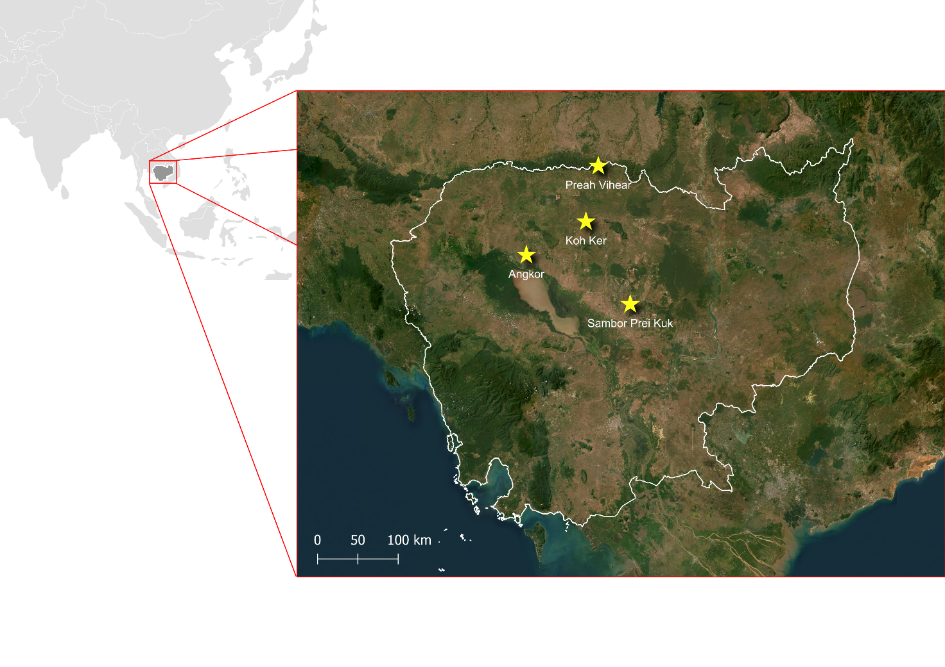
Figure 3. Cambodia’s World Heritage Khmer sites. Source:
Data from UNESCO; ESRI Satellite / Created by author.

Site Designation | Inscription | OUV | Protection Body
Angkor Archaeological Park | 1992 | (i), (ii), (iii), (iv) | APSARA National Authority
Temple of Preah Vihear | 2008 | (i) | National Authority for Preah Vihear (NAPV)
Temple Zone of Sambor Prei Kuk, Archaeological Site of Ancient Ishanapura | 2017 | (ii)(iii)(vi) | National Authority for Sambor Prei Kuk (NASPK)
Koh Ker: Archaeological Site of Ancient Lingapura or Chok Gargyar | 2023 | (ii), (iv) | National Authority for Preah Vihear (NAPV)

Table 1. UNESCO World Heritage Khmer sites inscription.

The Operational Guidelines delineate a protection and management framework: "All properties inscribed on the World Heritage List must have adequate long-term legislative, regulatory, institutional and/or traditional protection and management to ensure their safeguarding" (UNESCO 2025). Cultural heritage sites require boundary delimitation encompassing areas highlighting Outstanding Universal Value (referred to as nominated property) and potential future research zones. Additionally, buffer zones surrounding areas governed by complementary legislation ensure the property's setting and integrity, alongside zoning for community occupation and economic land use.

2.1. Pre-Angkorian Foundations: The Chenla Empire
Historical contextualization of the Khmer heritage is essential to understanding the four UNESCO sites analyzed in this case study. Khmer history dates back to the 1st century CE amid the maritime Silk Routes linking the Chinese (Qin/Han) and Roman empires through Funan trading hubs in the Mekong Delta, exchanging agricultural surpluses and metals (Coe 2003). Sanskrit inscriptions reveal cultural continuity among city-states, with trade routes facilitating syncretic adoption of Indian religious elements and cosmology via elite alliances rather than colonization, a process termed “Indianization” (Briggs 1951; Coe 2003; Stark 2006). This top-down process of overlaying local animist beliefs with Hinduism also enhanced the legitimacy of rulers, though internal royal divisions persisted due to the large number of heirs and the use of maternal lineage as a criterion for succession (Stark 2006).
The decline of Funan coincided with large-scale external events, such as the dissolution of the Han Dynasty and the subsequent reduction in trade flow, as well as with migrations of the Cham peoples, originating from peninsular Malaysia or Borneo, who initially settled in the highlands adjacent to the Mekong delta, in what is now Vietnam, before expanding towards the delta (Coe 2003). Although Figure 4 presents modern territorial boundaries, it also allows identification of the Mekong Delta and regional orography. The Funan population gradually migrated westward, establishing the Chenla (Zhenla) Kingdom. The capital city of Isanapura (Sambor Prei Kuk) was founded in the 7th century CE by Isanavarman I, inaugurating the so-called “Pre-Angkor Period” (Coe 2003). In this way, Khmer society transitioned from a trading society to one based on subsistence agriculture, specializing in managing monsoon cycles through hydraulic systems (Stark 2006).
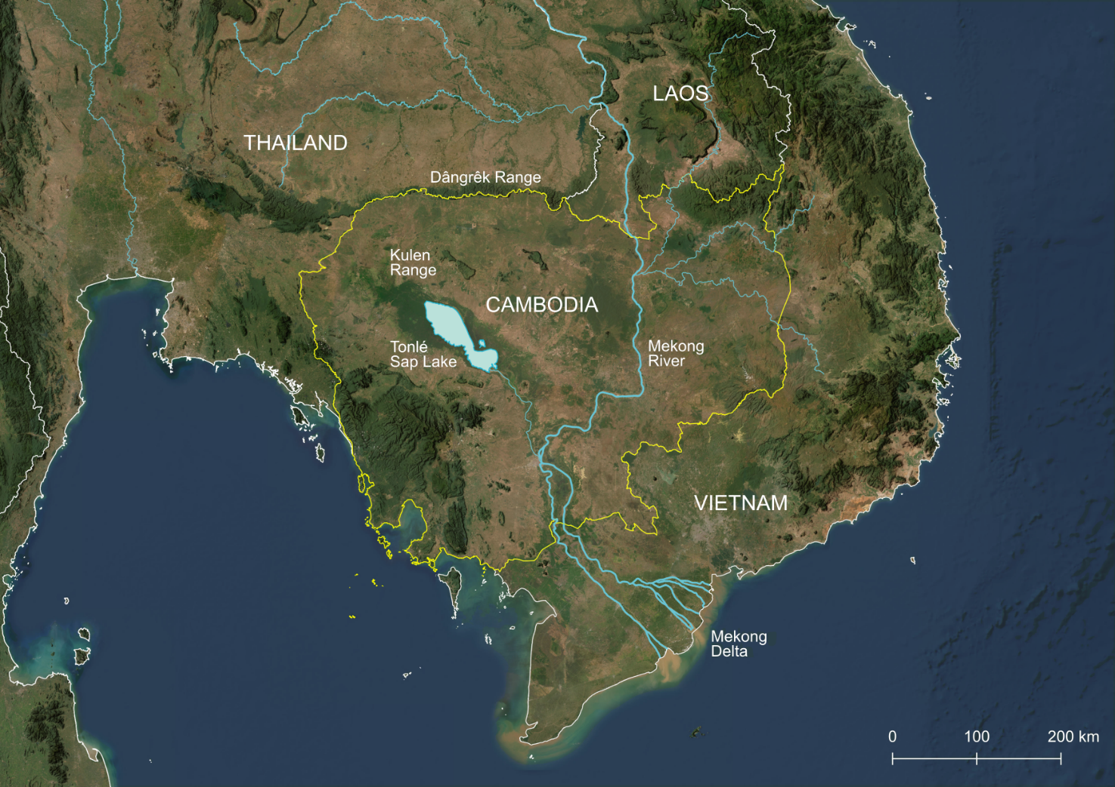
Legend
Cambodia boundary
International boundaries
Mekong River
Mekong tributaries
Figure 4. Physical geography of Cambodia and its adjacent areas, including the Mekong River and its tributaries.
Source: ESRI Satellite, opendevelopmentmekong.net, gadm.org / Created by author.

Sambor Prei Kuk already exhibited foundational elements that would later become patterns in the following Khmer periods. First, monumentality: each king commissioned additional temples, forming architectural ensembles structured around Hindu cosmology; initially constructed of brick but later incorporating laterite after the development of the iron industry enabled its extraction (Hendrickson and Evans 2015). Construction relied on communal corvée labor, war prisoners, and khñum (temple servants) (Coe 2003). Second, hydraulic engineering: extensive artificial water networks facilitated wet-rice cultivation across the Mekong Valley and the Tonlé Sap plains, providing control over seasonal flooding. These systems also included water reservoirs that, beyond fulfilling religious functions, helped regulate the humidity of the clay soils on which the temples were built, preventing the soil from contracting during dry periods and damaging their structural stability. The abandonment and drying of these reservoirs were, in many cases, major factors behind the collapse of numerous edifices (Coe 2003). Third, Khmer script development: although Khmer-speaking elites used Sanskrit writing during the Funan period, a vernacular script gradually emerged for administrative purposes while Sanskrit persisted in royal and ceremonial contexts (Stark 2006).
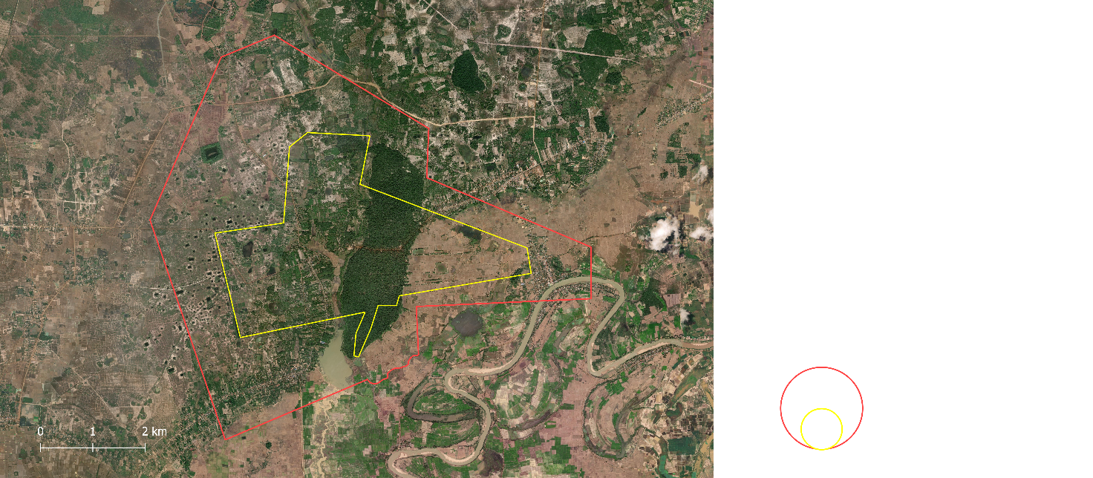
Buffer Zone
Nominated property

Legend

Figure 5. Sambor Prei Kuk temple. Source:
Data from UNESCO; ESRI Satellite / Created by author.

The Temple of Sambor Prei Kuk site (Figure 5) nominated property covers an area of 840 hectares, or 2,523.6 hectares including the buffer zone. It is located in Kampong Thom province and is supported by the National Authority for Sambor Prei Kuk (NASPK), a public administrative organization under the Ministry of Culture and Fine Arts, responsible for its Management Plan and the fifteen-year Conservation Plan.
The Chenla Kingdom comprised other prominent cities, such as Banteay Prei Nokor and Champassak, which, much like during the Funan period, enjoyed considerable autonomy. Central authority fluctuated between rulers, resulting in periods of stronger or weaker control (Stark 2006). This local autonomy was further reinforced by the fact that the Khmer never developed a monetary system; trade occurred through the barter of agricultural surplus, handicrafts, minerals, and metals (Stark 2006). This fragmented configuration changed with the rise of Jayavarman II in 802, inaugurating the so-called “Angkorian Period” (Coe 2003).

2.2 The Angkorian Period and the Theocratic Landscape
Jayavarman II altered the rules of succession to a patrilineal system, employed military force to expand Khmer territory westward, and declared himself chakravartin (“universal monarch”) under Hindu rites, becoming the personification of a deity (Coe 2003). The king of the emerging Khmer Empire established a new capital north of the Tonlé Sap Lake, at Hariharalaya, corresponding to today's Roluos Group within the Angkor UNESCO World Heritage site (See Figure 9). His successors continued this expansion, marking the extent of imperial territory through the construction of cities and temples, many of them in difficult-to-access locations (Coe 2003), such as Preah Vihear temple, another UNESCO World Heritage site built atop the Dangrek mountain range.
Legend

International Boundary (white)
Buffer Zone
Nominated property

Thailand
Cambodia
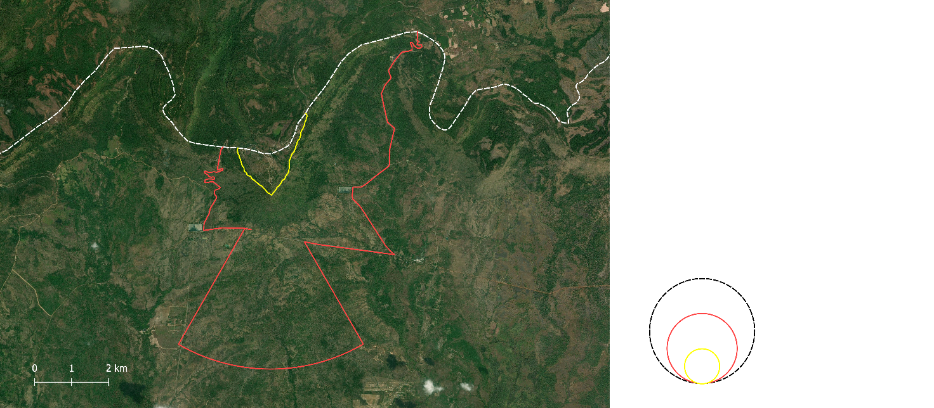
Figure 6. Preah Vihear temple. Source:
Data from UNESCO; ESRI Satellite / Created by author.

The Temple of Preah Vihear site (Figure 6) nominated property includes all areas above 500 meters in altitude and covers 154.7 hectares, or 2,642.5 hectares including the buffer zone. The buffer zone was delineated using preexisting roads in the area and a conical sector with a 60-degree angle and a 5-kilometer radius from the temple’s promontory, intended to preserve the forest landscape view from the temple. It is located in Preah Vihear province, on the edge of a plateau marking the border between Thailand and Cambodia. The site is supported by the National Authority for Preah Vihear (NAPV), a public administrative organization under the Ministry of Culture and Fine Arts which, in cooperation with the International Coordinating Committee (ICC), is responsible for the Sustainable Development Plan, the Tourism Management Plan, and the Risk Map (UNESCO 2025), none of which are publicly available on the UNESCO website or on the NAPV website. The area where the temple is located was historically disputed with Thailand, and this conflict will be discussed at the end of this chapter.
The region between the shores of the Tonlé Sap and the Kulen Range proved suitable for supplying water to a growing city. The practice of constructing temple complexes for each newly crowned ruler extended the axes of urban occupation, gradually shifting the city’s center of gravity to the west (Coe 2003). In 890, Yasovarman I founded Yasodharapura (Angkor), which would remain the imperial capital until the end of the Angkorian Period, except for a brief interval when another coexisting capital, Chok Gargyar (Koh Ker), was established in the Kulen Range (See Figure 4) by Jayavarman IV.
Koh Ker was built for reasons that remain uncertain. The city served as the capital of the Khmer Empire from 928 to 941, after which the court returned to Angkor following Jayavarman IV’s death. The site features Prasat Thom, a large seven-stepped pyramid and extensive infrastructure for rainwater collection, since its location atop the Kulen plateau did not offer the same availability of fresh surface water as the lower Angkor city (Coe 2003). Another consequence of its relative isolation is the large number of unlooted sandstone sculptures recovered during nineteenth-century expeditions by the École Française d’Extrême-Orient (EFEO), an abundant material due to its proximity to the sandstone quarries that supplied Angkor, which used sandstone as a replacement for brick in temple construction (Coe 2003).
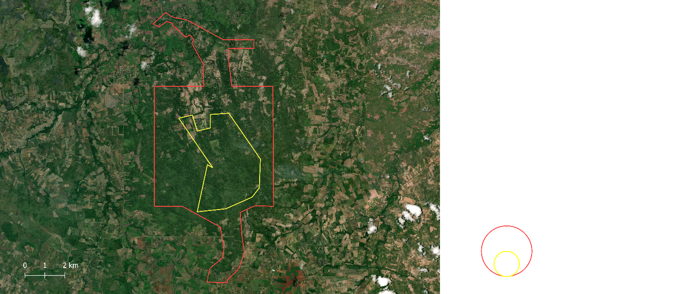
Buffer Zone
Nominated property

Legend

Figure 7. Koh Ker complex.
Source: Data from UNESCO, ESRI Satellite / Created by author.

Koh Ker complex site (Figure 7) nominated property covers an area of 1,187.6 hectares, or 3,523.7 hectares when including the buffer zone. It is located in Preah Vihear province and is supported by the NAPV, in cooperation with the International Coordinating Committee (ICC), which is responsible for the Management Plan, the Tourism Management Plan, and the Risk Map (UNESCO, 2025).
After the death of Jayavarman IV and the return of the capital to Angkor, a period of disintegration followed due to political instability. In 961, after a dynastic succession, the Buddhist Rajendravarman I was crowned emperor. Although Buddhism was present at the margins of the Khmer Empire, it did not yet play a significant political role. The new ruler commissioned the construction of Banteay Srei (see Figure 8), another temple complex within the Angkor World Heritage site (see Figure 9), intricately carved from reddish sandstone. Although built with Hinduist iconography, this temple hinted at early hybrid elements between Hinduism and Buddhism, and it would remain an exception as Rajendravarman’s son, Jayavarman V, reverted to Hinduism. Nearly two centuries would pass before another Buddhist ruler ascended the throne (Coe 2003).
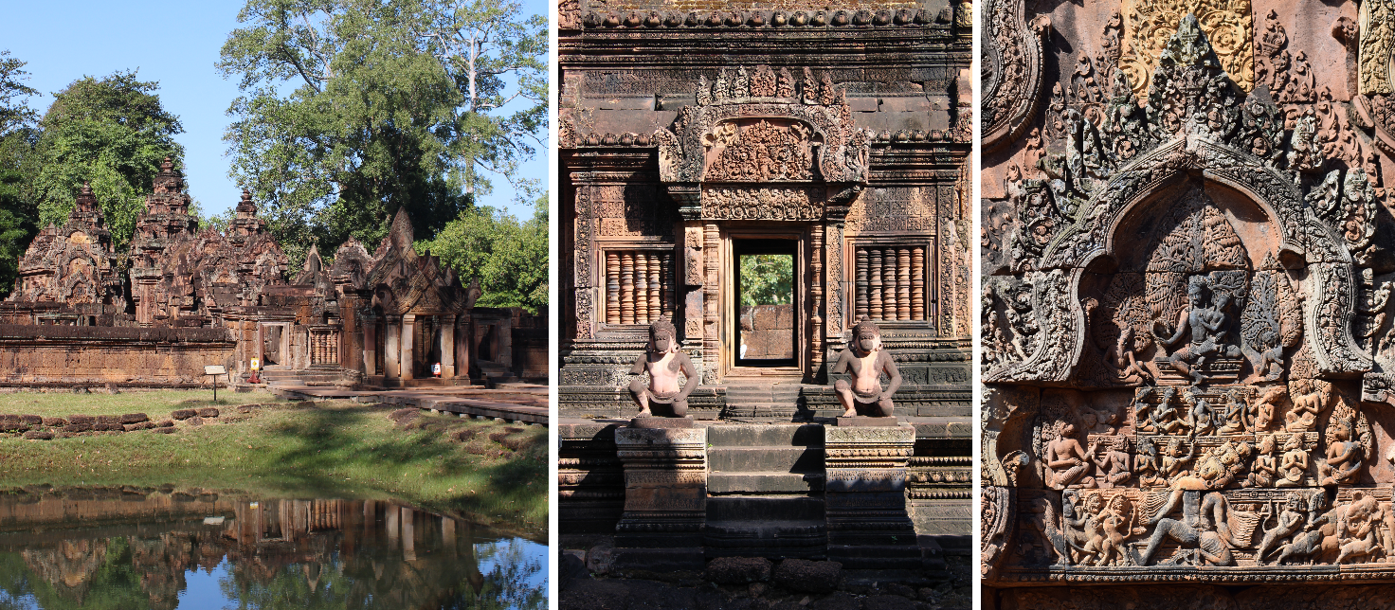
Figure 8. Image collage of Banteay Srei showing the temple complex, architecture, and carved details.
Source: Photos by author

The Khmer Empire maintained its stability and expanded militarily into regions of present-day central Thailand and south of Laos. The empire also extended its urban network by constructing hydraulic infrastructures and temples. The most notable temple construction is undoubtedly Angkor Wat (see Figure 9). Commissioned by Suryavarman II in 1113 and completed around his death in 1150, this temple remains the world’s largest religious structure and, together with the surrounding temples, barays (reservoirs), and canals, forms an anthropical “theocratic landscape”, where the landscape itself functioned as a politico-religious control system (Coningham et al. 2007). Angkor Wat is a temple complex covering 21 hectares, structured in three levels with concentric galleries and terraces. Its bas-reliefs depict Hindu mythological and epic scenes, while its central towers symbolize Mount Meru, the cosmic abode of the gods (Coe, 2003).
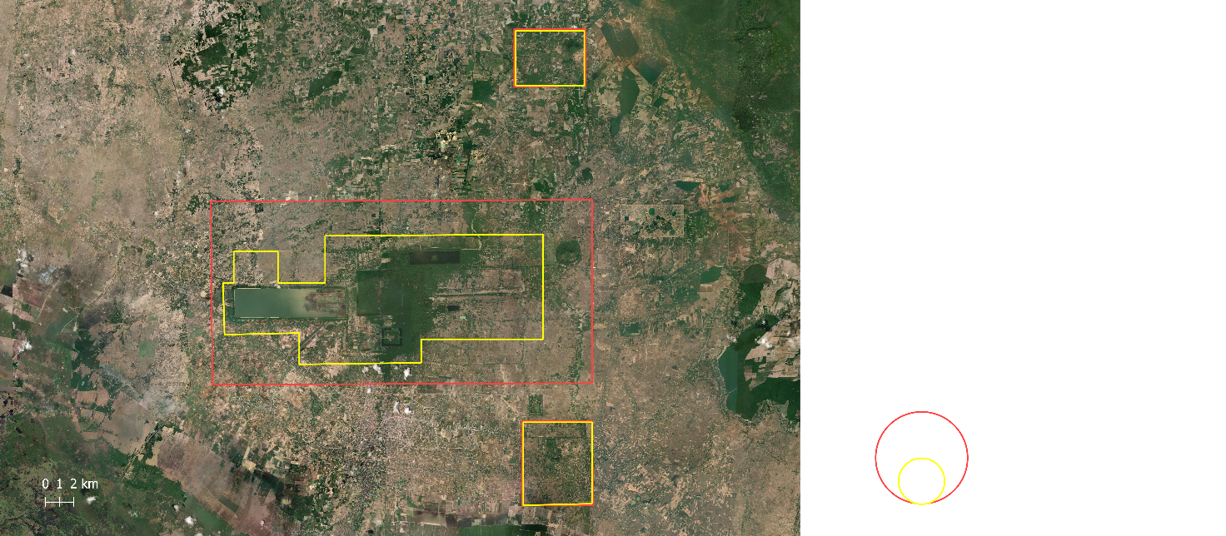
Legend

1 – Angkor
2 – Banteay Srei
3 – Roluos

Buffer Zone
Nominated property

2
1
3
Figure 9. Angkor Wat complex.
Source: Data from UNESCO; ESRI Satellite / Created by author.

The Angkor Complex (depicted in Figure 9) is divided into three parts: Angkor, Banteay Srei, and Roluos. The nominated property covers an area of 20,800 hectares, or 40,100 hectares when including the buffer zone. It is located in Siem Reap Province and supported by The Authority for the Protection and Management of Angkor and the Region of Siem Reap (APSARA), a public administrative organization under the Ministry of Culture and Fine Arts responsible for the Angkor Heritage Management Framework (AHMF), the Community Development Participation Project (CDPP), the Tourism Management Plan, and the Risk Map for monuments and natural resources. The site was included on the List of World Heritage in Danger from 1992 to 2004, during which time emergency planning and corrective actions were required (UNESCO 2025).
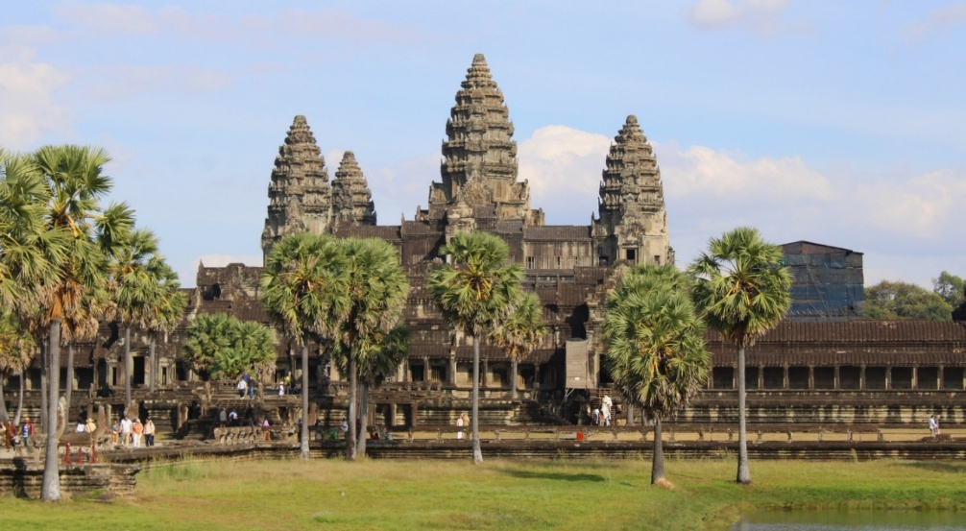
Figure 10. Angkor Wat temple.
Source: Photo by author.

Following prosperity came instability with the 1177 Cham invasion up the Mekong to Tonlé Sap, sacking Angkor and assassinating the king (Coe 2003). Jayavarman VII expelled the Cham four years later, consolidating power in his fifties through naval victories memorialized in the Bayon temple reliefs which depicts Tonlé Sap as a "lake of blood" (Coe 2003).
Jayavarman VII's reign marked Angkor's zenith. He built Angkor Thom, featuring temples, terraces, reservoirs, and its masterpiece, the Bayon: a Mahayana Buddhist temple with 54 towers bearing 216 Avalokitesvara faces (Coe 2003). The monarch also constructed and restored many decaying Hinduist temples, roads, Dharmasalas (rest houses), and Arogyasalas (hospitals), thereby curbing the chaos of city-state independence but cultivating an image as a benevolent and tolerant ruler. (Hingham 2008)
His successor, Indravarman II (1218–1243), continued the Buddhist legacy but also faced external threats, this time from Dai Viet, a Vietnamese polity competing for control of Champa territories in the Mekong Delta, as well as Khmer territories, on the eastern frontier. At the same time, internal insurrections against Buddhist primacy with iconoclastic movements reoriented Buddhist temples to Hinduism, destroyed Buddhist images and sculptures, a process that intensified during the reign of Jayavarman VIII (1243–1295), marking a dramatic shift away from the established panorama where the religions coexisted in balance for centuries (Coe 2003).
From this transitional period into the 14th century, stone scripts (the main source for Cambodian history) became scarce (Vickery 2004); the last known Sanskrit inscription dates to 1327, recording the coronation of Jayavarmadiparameshvara (Coe 2003). The collapse of the imperial system was heralded by renewed fragmentation among city-states. Numerous theories account for the Khmer Empire's imminent decline: from overtaxation due to Jayavarman VII's massive construction projects, which exhausted the population on the corvée system (Briggs 1951), to the spread of Theravada Buddhism, a doctrine that undermined the ideology of religious and imperial subservience and would erode the Khmer State’s resilience and its capacity for reconstruction (Briggs, 1951); climatic factors, such as prolonged droughts in the 14th and 15th centuries, which exceeded the capacity of hydraulic systems and generated severe stresses on Khmer agriculture (Buckley et al. 2010). Most significantly, however, persistent external pressures from the east by Dai Viet and from the west by Ayutthaya, a Thai Kingdom, were steadily absorbing Khmer territories. The capital, however, persisted for another century amid economic decline (Coe 2003).
After two years of siege, in 1431, Siamese (Thai) troops invaded, sacked, and controlled Angkor, marking the end of the Khmer Empire and the Angkorian period (Stark 2006). Following the pillage, the city of Angkor and the other urban centers of the Khmer Empire were gradually abandoned and swallowed by the forest. The Khmer migrated eastward to the confluence of the Tonlé Sap outflow with the Mekong, founding Phnom Penh as the new capital, definitively altering Khmer lifeways and solidifying the adoption of Theravada Buddhism.

2.3 Post-Angkorian period to Modern Cambodia
Although this study adopts Khmer objects, publications, and projects from the Angkorian period as a case study, the historical trajectory following the decline of the Khmer Empire is also essential for understanding the present configuration of these elements. Following the collapse of the Khmer Empire, Cambodia entered an intermediate phase, from the 15th to the 19th century (Vickery 2004; Coe 2003), marked by political subordination as a buffer state between Siam (Thailand) and Vietnam. Due to political instability and the fragility of local transmission practices, primary Khmer sources from this era are scarce, leaving historians to rely on external accounts, including Thai archives and records from foreign merchants and pilgrims. However, an internal perspective gradually emerged through the Phongsavadar (Royal Chronicles), which combine history with mythical narratives (Coningham et al. 2008).
This era saw a profound social and religious transformation. The court moved to Phnom Penh, and the monarchy ceased constructing monumental stone works. The shift from Hinduism to Theravada Buddhism introduced a more egalitarian and individualized religiosity. Temples became smaller, wooden, and more intimate, while monastic life became accessible to the common people. Economically, the country shifted toward maritime trade, with the port of Longvek becoming a cosmopolitan hub for Asian and European merchants (Vickery, 2004).
Despite the shift in power and territorial control, Khmer temples were never fully abandoned; Angkor Wat, in particular, transitioned from a political center to a Buddhist pilgrimage site. Sixteenth-century accounts by Portuguese missionaries attest to ongoing monastic activity (Vickery 2004), while seventeenth-century Japanese and Chinese graffiti provide further evidence of continued pilgrimage (Coe, 2003). In contrast, more peripheral temple complexes, such as Koh Ker, were largely reclaimed by the surrounding forest, and the lack of maintenance of their structures, as well as of hydraulic systems such as reservoirs and canals, led to their gradual deterioration.
The intermediate period ended in 1863, when King Norodom sought a French protectorate to ensure the kingdom's survival against Siamese and Vietnamese encroachment, leading to Cambodia’s incorporation into French Indochina. The colonial administration significantly restructured the political and economic landscape by the introduction of private landownership (thereby diminishing the king’s absolute rights), tax reforms, and the abolition of slavery (Tully 2000). Critically, the French mission civilisatrice placed a heavy emphasis on the study and preservation of Khmer cultural heritage.
In 1898, France established the École Française d’Extrême-Orient (EFEO) to undertake the systematic documentation and restoration of Angkorian monuments. While this institution pioneered modern conservation practices, it also facilitated the removal of artifacts to European institutions, such as the Musée Guimet. EFEO scholars defined the criteria for the presentation of temples and ruins, including decisions on which structures should be restored, the methodologies to be employed in restoration, and which elements should be preserved in their existing condition. In practice, much of what is visible at these sites today, and their nomenclature, results from these colonial-era interventions (Tully 2006).
Geopolitically, the 1907 Franco-Siamese Treaty delineated the contours of Cambodia’s modern borders, while also laying the groundwork for subsequent territorial disputes by assigning the Preah Vihear temple to Cambodian territory despite Siamese claims. French rule was briefly interrupted by Japanese occupation during WWII, a disruption that ultimately catalyzed the Khmer independence movement, leading to full sovereignty in 1953 (Tully 2000).
In the post-independence period, Cambodia, under the leadership of Norodom Sihanouk, initially pursued a policy of neutrality during the Cold War. However, by the late 1960s, the country was destabilized by internal dissent and the spillover of the Vietnam War (Tully 2000). Following a military coup in 1970, Cambodia descended into civil war, which culminated in 1975 with the seizure of power by the Communist Party of Kampuchea, commonly known as the Khmer Rouge, under the leadership of Pol Pot (Tully 2000).
The Democratic Kampuchea regime implemented a radical and violent agrarian utopia. Cities were evacuated compelling urban populations into rural labor camps, money was abolished, and "class enemies" were executed. Pol Pot’s vision fused secularist communism with an idealized agrarian Angkorian past, prioritizing the Khmer Empire’s modes of production over its religious significance. This period saw the deliberate destruction of cultural heritage through vandalism and the emergence of a global trafficking network for looted artifacts, which continues to pose significant provenance challenges and data gaps in the modern record. Furthermore, thousands of landmines were scattered near historic temples, creating a “legacy of terror” that hampered conservation and archaeological research for decades (Davis 2011).
After the Khmer Rouge fell in 1979, a decade of Vietnamese occupation followed, providing limited stabilization until the 1991 Paris Peace Agreements paved the way for United Nation-supervised elections and the return of the monarchy (Tully 2000).
Since the 1990s, Cambodia has focused on reconstruction and heritage governance. Following Cambodia’s inscription of Angkor on the UNESCO World Heritage List in 1992, the establishment of the APSARA National Authority in 1995 marked a new era of professional management of Khmer heritage, supported by international partners such as Japan and France. Under King Norodom Sihamoni, cultural heritage has become central to national identity and a booming tourism industry.
Modern Cambodia has also become a leader in repatriation, successfully reclaiming looted sculptures from major institutions like the Metropolitan Museum of Art (MET) following recognition of their illicit wartime origins. Two decades of political stability have established Cambodia as a central hub for archaeological and conservation research in Southeast Asia. This growth fostered a heritage-centered agenda tied to tourism, which peaked in 2019 with 6.6 million international visitors before the 2020 pandemic downturn.
However, heritage remains vulnerable to geopolitical and environmental pressures; as recently as 2025, border clashes on the Preah Vihear temple and its adjacencies underscored the persistent threat of physical destruction. While digitalization cannot prevent physical damage from conflicts, environmental degradation, or climate change, it serves as a critical resilience strategy by creating a permanent record of the monuments' condition. Expanding access to this information through digital means facilitates a multi-layered engagement: it provides educational transparency for local communities, immersive engagement for the tourism sector, and interoperable, open-access data for the international research community.

Chapter 3. Research and Methodology
This chapter presents the development of the work carried out to construct the model, addressing its research questions and objectives, as well as the methodology used to obtain the case study data and to design and implement the model as a Knowledge Graph.

3.1 Research Question and Objectives
The research question of this study is:
How can fragmented data be integrated to provide a comprehensive digital representation of a domain in cultural heritage within the Semantic Web?
To address this question, the study explores the following objectives:
- The aggregation and harmonization of data characterized by heterogeneous metadata standards, originating from cultural heritage institutions and external fields.
- The alignment of diverse metadata description practices within a formal semantic modeling framework based on widely adopted ontologies.
- The management of variability in temporal and spatial attributions, aiming to reduce ambiguity in abstract temporal mappings and uncertain geographic provenance.
- The use of integrated datasets to generate new forms of knowledge, as well as visualization methods that enhance access and interaction for diverse audiences.
- The contextualization of the geographical displacement of objects over time and the examination of the shifts in scientific and conservation paradigms across different periods.
This research question arises from the hypothesis that a platform linking information from fragmented sources can enhance accessibility and interpretability, and that this model can be replicated in contexts beyond the case study with the necessary adaptations.

3.2 Methodology
This study adopts the Simple Knowledge-Engineering Methodology proposed by Noy and McGuinness (2001). The methodology is grounded in the premise that knowledge may be represented through multiple conceptual structures and that the intended purpose and application context of the ontology should guide ontological design decisions. Accordingly, ontology development is conceived as an iterative and incremental process comprising the following stages:
- Definition of the domain: this study seeks to unify Khmer heritage information under a single ontology, drawing on four areas of knowledge production with distinct archival traditions: (i) publications in scientific repositories, (ii) movable cultural objects in museums, (iii) geolocated immovable cultural objects, and (iv) reports from in situ projects. Based on this scope, a set of competency questions was formulated to guide the ontology engineering process and to support the subsequent validation of the ontological representation. The following competency questions exemplify the intended analytical capabilities of the ontology:
- Which areas of knowledge produce publications related to Khmer heritage?
- Which museum objects are associated with the Bayon Temple?
- Which countries host institutions preserving objects dating from the ninth century?
- Which materials were employed in the construction of temples at Sambor Prei Kuk?
- Which institutions produce the largest volume of publications concerning Preah Vihear Temple?
- Which projects focus on constructions commissioned during the reign of Jayavarman IV?

- Reuse existing ontologies: for interoperability purposes, all classes and properties used in this ontology are reused from existing ontologies. The overall architectural structure of the model is grounded in CIDOC CRM (ISO 21127:2023), the international standard for cultural heritage information management, complemented by additional ontologies (DC, Bibo, Geo, FOAF, Schema, RDFS) to facilitate the integration of data from other fields.
- Enumerate important terms: This study identifies numerous terms with classificatory functions, such as types of immovable cultural objects (temple, terrace, bridge, reservoir, arogyasala) and materials composing movable cultural objects (sandstone, bronze, gold), among others. These terms are assigned a regulated semantic value through controlled vocabularies and thesauri.
- Define the classes and the class hierarchy: The classes used are provided by their respective ontologies, such as dct:BibliographicalResource and crm:E27_Site, and their hierarchies follow the formal axioms established by those ontologies.
- Define the properties of classes and
- Define the facets of the slots: As classes, the properties used in this model are provided by the source ontologies, such as rdfs:subClassOf and crm:P108i_was_made_by, along with their slot-value types (string, integer, float, boolean) and their domain and range. Their hierarchies follow the formal axioms established by those ontologies. For instance, in the property crm:P108i_was_made_by, the suffix “i” associated with “P108” designates the inverse relation from the original property crm:P108_has_produced, following the conventions defined by CIDOC CRM.
- Create instances: Establish conventions for data standardization, whether for naming (case sensitivity, prefixes and suffixes, abbreviations) and for managing dates and times. This study standardizes data nomenclature, accounting for platform-specific metadata differences, and adopts ISO 8601 to represent dates and times consistently; its implementation is detailed in the Sources and Datasets section.

3.2.1 Sources and Datasets
To construct the dataset, data acquisition and processing were conducted across the four axes constituting the proposed model: Museum Collections (movable cultural objects); Bibliographic Repositories (scientific research publications); Archaeological and Geospatial Resources (immovable cultural heritage with spatial context); and Reports of Projects (ongoing conservation and research initiatives). Data were systematically collected to build a representative sample dataset for a Khmer culture case study, rather than the complete corpus for each axis. These datasets are hosted in the project's GitHub repository [Link] and available for consultation.
Data acquisition varied according to the nature of the source and the degree of accessibility to the information. The keywords used for database searches were the names (and their variants) of the studied sites (Angkor, Preah Vihear, Koh Ker, Sambor Prei Kuk) and “Khmer.”
- Museum Collections: Primary sources include the Guimet Museum, the National Museum of Cambodia, the Cernuschi Museum, the Loire Museum (all previously mentioned accessed via the Grand Palais RMN), the Museum of Asian Art (Berlin), the British Museum, the Metropolitan Museum of Art, and the Cleveland Museum of Art.
- Bibliographic Repositories: Sources include major academic databases, Web of Science, Scopus, and Google Scholar.
- Archaeological and Geospatial Resources: Sources comprise UNESCO World Heritage documentation, Cultural Management Plans, and open geospatial repositories such as the United States Geological Survey (USGS), Esri Open Data, and OpenStreetMap.
- Projects Reports: Sources include institutional reports produced by the APSARA National Authority, UNESCO, and international cooperation programs.
The extraction strategy was tailored according to the data accessibility of the source:
- API and Structured Exports: For institutions with advanced digital infrastructures, such as the Metropolitan Museum of Art and the Cleveland Museum of Art, data were retrieved via REST APIs, returning structured JSON metadata. The British Museum datasets were obtained via CSV exports, while bibliographic data from Web of Science and Scopus were extracted in BibTeX format.
- Web-Based Extraction: Data from the Grand Palais RMN and the Staatliche Museen zu Berlin were aggregated through their respective open-access platforms, querying specific keywords (e.g., "Khmer", "Angkor") to retrieve images (TIFF and JPG formats) and metadata, then manually aggregating.
- Manual Data Collection: Due to the absence of machine-readable exports, data from Google Scholar, APSARA institutional reports, and UNESCO Cultural Management Plans were manually extracted. This process involved synthesizing narrative reports and PDF documentation into a structured internal database.
- Geospatial Processing: Spatial boundaries and heritage zones were derived from shapefiles downloaded from GIS repositories or digitized directly from official heritage boundary definitions.
Following the acquisition phase, the raw data underwent processes of cleaning and enrichment to ensure interoperability across the four axes. For each axis, a different sampling strategy was used to maintain a representative balance.
For bibliographic data, a corrected proportional sampling strategy was applied. It is important to note that Angkor generates a significantly higher volume of publications than the other sites, reflecting its historical significance and scholarly prominence. However, the term “Angkor” is also used in a broader sense, often encompassing multiple archaeological locations and related heritage contexts; therefore, a manual disambiguation process was undertaken to ensure semantic precision. As a result, a corrected proportional distribution of 5:2:2:1 was established. Within this framework, a minimum threshold of 20 publications was defined for Sambor Prei Kuk. Although this allocation is intentionally disproportionate relative to Angkor, it preserves controlled proportional relationships among the remaining sites while preventing underrepresentation of less-documented corpora.
For museum data, a corrected proportional sampling strategy was applied based on the number of objects on display within each institution. Consequently, institutions such as Musée Guimet and the National Museum of Cambodia are more heavily represented due to their larger publicly accessible collections. However, the sampling strategy was not strictly proportional. A maximum threshold of 50 records per institution was established to prevent overrepresentation of larger collections. Conversely, in cases where institutions contained only a limited number of relevant records, a complete census of available data was performed, resulting in very small subsets (e.g., 1 to 4 entries for certain institutions).
It should also be noted that the metadata for the National Museum of Cambodia items originates from French institutional catalogs and reflects objects initially documented during the French colonial period. Furthermore, digital datasets were not available on the websites of Cambodian institutions, which constrained the completeness of the corpus.
Regarding geospatial data, information was collected exclusively for temples and structures located within the nominated property boundaries, excluding buffer zones. An exception was made for Preah Vihear, whose management plan does not provide sufficiently granular spatial data for individual architectural components or structures, and because part of its associated architectural remains extend beyond the contemporary Cambodian border into Thai territory.
Each dataset was subsequently mapped to a standardized schema composed of interlinkable attributes, conceived to support diverse methods of categorization and visualization:
- Museum Objects: (Label, Identifier, Type, Description, Religion, Dimension, Representation, Use, Medium, Current Keeper, Current Location, Acquisition Date, Production Location, Time-Span, Ruler).
- Scientific Publications: (Title, Type, Identifier, Affiliation, Provenance, Year, Authors, Language, Publisher, Keywords, Journal, Book, Abstract, Spatial Coverage, Field).
- Archaeological and Geospatial Resources: (Name, Native name, Alternative names, Typology, Condition, Religion, Contextual Site, Geometry, City, District, Province, Country, Time-Span, Builder, Latitude, Longitude, Material).
- Project reports: (Title, Acronym, Identifier, Scope, Status, Start date, End date, Contextual Site, Specific Site, Time-Span, Organization, Authority, Responsible, Funder, Field, Activities, Material Focus, Generated outputs).
To address the challenges of Khmer heritage representation, specifically the inconsistencies between absolute dates and stylistic periods across different institutions, a normalization logic was applied to enable computational processing of temporal data. This logic involves converting abstract descriptors, such as "Late 11th Century," into standardized ISO 8601 date ranges (e.g., 1075-01-01 to 1100-12-31). Furthermore, specific art styles, such as “Bayon Style” or “Koh Ker Style,” are mapped to their historically accepted chronologies to establish an "average date" for quantitative analysis. The resulting system is inherently hybrid, allowing for the seamless coexistence of precise modern dates alongside these estimated historical ranges.
Many sites and objects carry multiple names across Khmer, French, and English. To prevent data duplication and ensure accurate retrieval, a Multilingual Mapping was taken. Specific columns were created to store Administrative names, Native Names (in Khmer), and Alternative Names.
A methodologically pragmatic decision was to adopt “Builder” and “Ruler” as points of convergence across the different axes. The majority of objects are not dated with precision but rather classified according to stylistic criteria. These styles, such as “Bayon Style” or “Koh Ker Style,” generally correspond to the reign of a particular ruler during the period of production, although this correlation may vary in reliability depending on the political stability of the time. In certain cases, particularly for objects lacking archaeological documentation, it is not possible to ascertain their exact place of production. As a result, the spatial attribution of some objects may extend beyond present-day Cambodia to regions such as Thailand and Vietnam, reflecting the historical territorial expansion of the Khmer Empire. However, for practical reasons, this project does not consider Khmer cultural heritage located outside Cambodia's contemporary boundaries.
The final stage focused on standardizing the storage and access of digital representations, a crucial step for the visualization methods planned for the future website. Because the source material consists of a wide variety of formats, the system manages two distinct layers: High-Resolution Assets, which include direct links and metadata for archival-grade images (such as TIFF or JPG) intended for visual analysis, and Referential Links, which are used when direct files are unavailable. These referential links store URLs that redirect users back to the original institutional landing page or to the object's digital surrogate within its native context.

3.3 Semantic Modeling (The Ontology)
This section introduces the conceptual model of the four axes that comprise the proposed ontology, establishing a logical compartmentalization for the representation of their respective domains. Furthermore, it details the integration of these axes into a unified, comprehensive ontology. The following list details the prefixes of the reused ontologies referenced in the subsequent subsection figures and descriptions:
bibo: <http://purl.org/ontology/bibo/>
crm:<http://www.cidoc-crm.org/cidoc-crm>
dct: <http://purl.org/dc/terms/>
foaf: <http://xmlns.com/foaf/0.1/>
geo: <http://www.opengis.net/ont/geosparql#>
owl: <http://www.w3.org/2002/07/owl#>
rdf: <http://www.w3.org/1999/02/22-rdf-syntax-ns#>
rdfs: <http://www.w3.org/2000/01/rdf-schema#>
schema: <http://schema.org/>
skos: <http://www.w3.org/2004/02/skos/core#>
wd: <http://www.wikidata.org/entity/>
wgs84: <http://www.w3.org/2003/01/geo/wgs84_pos#>

3.3.1. Museum Collections

The first axis of the conceptual model, as depicted in Figure 11, represents movable cultural heritage objects within museum collections. It uses CRM as a core ontology, integrated with complementary vocabularies for interoperability. Although each institution utilizes its own metadata standards, several core elements are consistently present across all datasets.
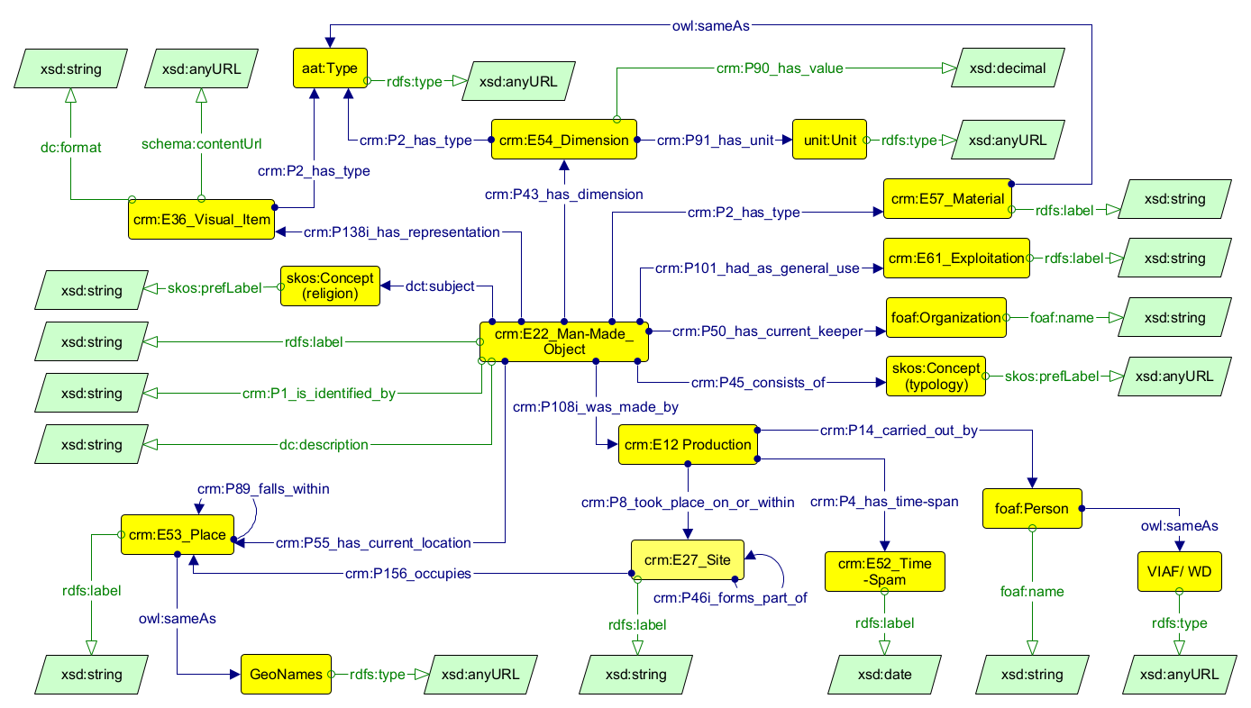

Figure 11. Museum Objects conceptual model

At the center of this conceptual model is the class crm:E22_Man-Made_Object, which serves as the primary entity for the physical artifact. This object is formally identified by labels and unique identifiers (assigned by its institution); It is further enriched with descriptive metadata and thematic classifications, such as the associated religion or typology, managed via skos:Concept, which allows the model to assign regulated semantic values by mapping local data to established external taxonomies, such as those provided by UNESCO.
The physical nature of the object is documented through its material composition, linked to the Art & Architecture Thesaurus (AAT) for standardized terms such as sandstone or brick, and its specific measurements, which are recorded using the crm:E54_Dimension class. To capture the historical lifecycle of the object, the model utilizes the crm:E12_Production event, which connects the artifact to its commissioner, modeled as a foaf:Person, and the specific time span of its creation. This temporal data is normalized using xsd:date to allow for precise computational analysis alongside broader historical periods.
The geographical provenance of the object is established by linking the production event to a crm:E27_Site, which in CRM is a subclass of crm:E18_Physical_Thing (just like crm:E22_Man-made object) and is further situated within a broader crm:E53_Place and cross-referenced with external authorities like GeoNames. Administratively, the model tracks the current custodian of the item via crm:P50_has_current_keeper property to the foaf:Organization class, representing institutions such as the National Museum of Cambodia or the Musée Guimet. Finally, to facilitate future digital visualization and research, the model includes a layer for digital representations via crm:E36_Visual_Item, which stores metadata for images or provides referential links back to the original institutional object page.
The datatypes associated with each class are represented in the green boxes, adhering to the standardized XSD (XML Schema Definition) format. These formats ensure computational consistency across the knowledge graph by defining specific value types, such as xsd:string for textual descriptions, xsd:date for normalized temporal data, and xsd:anyURL for external web resources and persistent identifiers. This structure is present in all subsequent models.

3.3.2. Scientific publications.
The second axis of the conceptual model, as depicted in Figure 12, is designed to represent publications concerning Khmer heritage, utilizing Dublin Core (DC) as the primary ontology to maintain structural simplicity. This choice avoids the need to create the numerous intermediate nodes required by the CRM event-centric architecture. To further refine the dataset, the Bibliographic Ontology (BIBO) is employed to facilitate the precise classification of instances through its specialized classes.
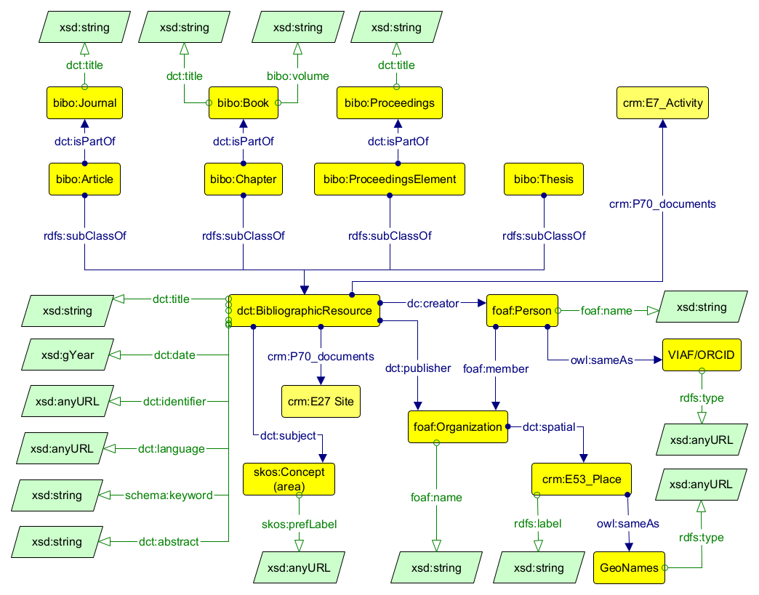
Figure 12. Scientific publication conceptual model

At the center of this conceptual model is the class dct:BibliographicResource, which serves as the general class for publications and is subsequently refined via rdfs:subClassOf property into specific subclasses, including bibo:Article, bibo:Chapter, bibo:ProceedingsElement, and bibo:Thesis. These are linked to their parent publications, such as a bibo:Journal or bibo:Book, using the dct:isPartOf property to preserve the entity's structural context. The Bibliographic Resource class also treats dct:title and dct:identifier as literals, whereas dct:language is described by the ISO 639 authority.
The model also implements a semantic representation of specific academic areas using skos:Concept linked via the dct:subject property. Contextual and specific content, such as dct:abstract and schema:keyword, is stored as standardized xsd:string literals due to subjectivity and the lack of uniformity in keyword assertions across different institutional datasets.
Authorship and institutional context are managed with an emphasis on authority control. Individual authors are represented as foaf:Person entities and are cross-referenced using academic identifiers such as ORCID or VIAF via owl:sameAs. The model represents the author’s institutional affiliation using foaf:Organization, situating it within a broader geographic context via crm:E53_Place, and disambiguating it via owl:sameAs to GeoNames. The identifier (dct:identifier) is the DOI of the publication, in xsd:anyURL datatype.
Finally, this axis acts as a critical semantic bridge between textual knowledge and physical heritage assets. Through the use of property crm:P70_documents, the model connects bibliographic resources to crm:E27_Site general or specific locations, such as Angkor Wat or Koh Ker Complex, as well as to specific crm:E7_Activity instances, such as conservation projects or excavations. The standardized temporal format xsd:gYear adopts the year of online publication as the primary reference point.

3.3.3 Places and monuments.
The third axis of the conceptual model, as depicted in Figure 13, is designed to represent the immovable cultural heritage objects and their geographical context, utilizing CRM as the primary ontology. At the center of this model is the class crm:E27_Site, which serves as the digital surrogate for architectural structures and archaeological sites. This axis ensures that fragmented spatial data is semantically aligned with the other axes of the knowledge graph.
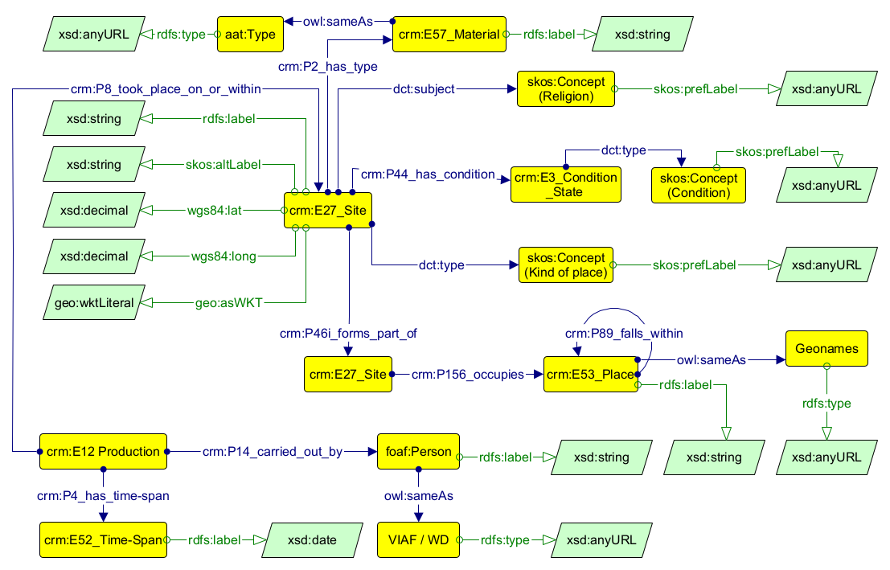
Figure 13. Places and Monuments conceptual model.

Geographical representation is achieved through a multi-layered approach to spatial data. Precise point geolocation is captured using wgs84:lat and wgs84:long coordinates, to locate temples and hydraulic structures. for instance, while more complex spatial boundaries, such as site perimeters, are defined through polygon geometries expressed as geo:asWKT using the geo:wktLiteral datatype. This spatial information is essential for enabling a range of visualization methods on the website. These sites are situated within a topological hierarchy via the crm:P156_occupies property which links them to crm:E53_Place, which is further disambiguated through external authority files like GeoNames. Nested relationships between structures, such as a temple forming part of a larger archaeological complex, are formally modeled using the crm:P46i_forms_part_of relationship; in the graph, this relationship is shown separately solely for visual clarity.
The physical and qualitative attributes of these immovable assets are documented through specific properties and controlled vocabularies. The material composition of a site is linked to the crm:E57_Material class, which is aligned with the Art & Architecture Thesaurus (AAT) to ensure standardized terminology for substances like sandstone or laterite. Furthermore, the conservation status of a site is captured through the crm:E3_Condition_State class, while its functional nature is categorized via a skos:Concept linked through the dct:type property.
Finally, the axis integrates the historical and cultural dimensions of the built environment by tracking production events and religious context. The crm:E12_Production event connects a site to its historical foundation, recording the crm:E52_Time-Span, normalized as xsd:date, and the human actors involved, who are modeled as foaf:Person and cross-referenced with VIAF or Wikidata. Given the significance of spirituality in the Khmer Empire, sites are also linked to specific religious traditions using a skos:Concept via the dct:subject property. Consistent with the rest of the model, all datatypes are defined using standardized XSD schemas.

3.3.4 Reports on Projects
The fourth axis of the conceptual model, as depicted in Figure 14, focuses on the documentation of cultural heritage activities, such as archaeological excavations and conservation projects, using crm:E7_Activity as the primary class. This axis integrates the human and institutional efforts directed toward movable and immovable heritage. Each activity is formally defined by a dct:title, dct:identifier, dct:description, and schema:alternateName to capture project acronyms.
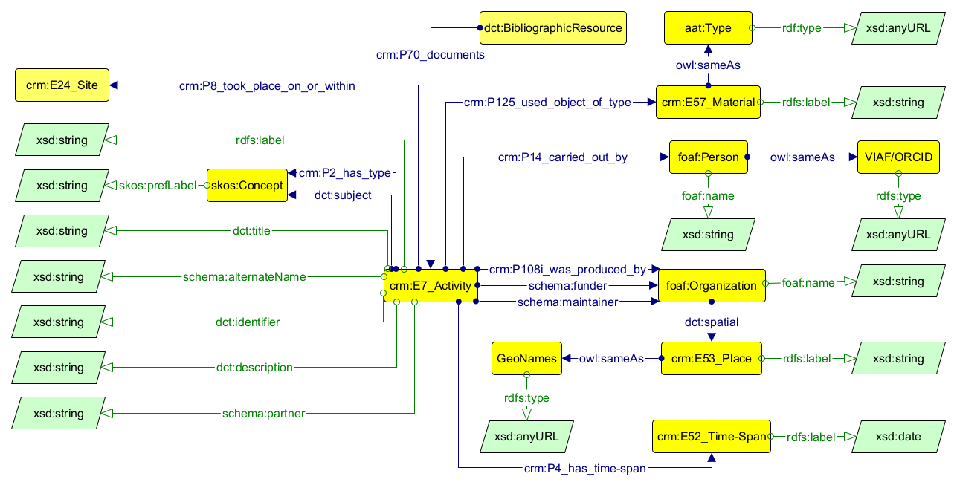
Figure 14. Activities and Projects conceptual model.

Semantic refinement of these activities is managed through specialized controlled vocabularies. The material focus of the activity is described by crm:E57_Material via the crm:P125_used_object_of_type property and cross-referenced with the AAT Thesaurus. The skos:Concept describes both the area of the work, such as archaeology or conservation, via dct:subject, while the administrative or operational state of the project is tracked via crm:P2_has_type relationship.
The human and institutional dimensions are captured in an activity as researchers via foaf:Person cross-referenced with VIAF/ORCID. Organizations are modeled as foaf:Organization entities, with specific roles assigned according to their function in the project: execution of the activity via crm:P108i_was_produced_by, financial support via schema:funder, and institutional oversight by national bodies such as APSARA National Authority via schema:maintainer. These institutions are situated geographically by linking them to a crm:E53_Place, which is disambiguated using GeoNames.
Finally, Activities are anchored in time using the crm:E52_Time-Span class. Activities are linked to their physical location (and to the third axis) through the crm:P8_took_place_on_or_within property to a crm:E27_Site. The evidential basis for these activities is maintained by linking them back to the second axis via the crm:P70_documents property, which associates the activity with a corresponding dct:BibliographicResource.
3.3.5 The Complete Ontology
The integrated conceptual model, as synthesized in Figure 15, clarifies the structural convergence of the four research axes into a unified Knowledge Graph for Khmer heritage. By abstracting the specific literals and authority files, the diagram highlights the semantic intersections between CRM, BIBO, DC, FOAF, and SKOS.
This comprehensive graph demonstrates how movable artifacts (crm:E22_Man-Made_Object), immovable sites (crm:E27_Site), documented activities (crm:E7_Activity), and bibliographic publications (dct:BibliographicResource) are interlinked through shared agents, temporal frameworks, and spatial contexts. The resulting architecture provides an interoperable structure for the exploration of Cultural Heritage data.
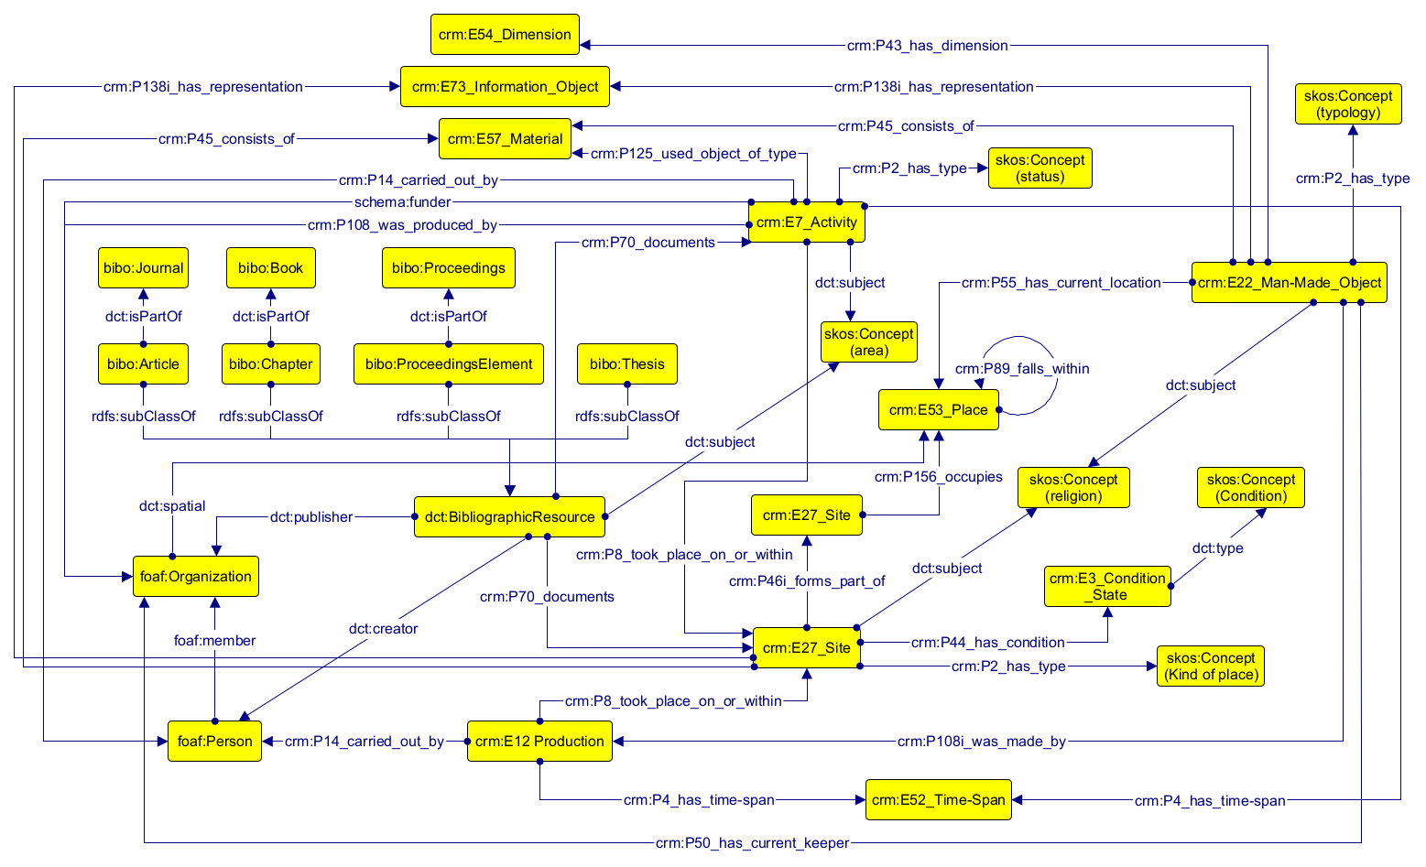
Figure 15. Complete conceptual model.

3.4. Knowledge graph

https://www.w3.org/TR/uri-clarification/; https://www.w3.org/policies/uri-persistence/
https://www.w3.org/2001/tag/doc/whenToUseGet.html
https://www.w3.org/TR/rdf-schema/
https://www.w3.org/TR/owl-ref/
https://json-ld.org/
https://cordis.europa.eu/datalab/sparql-endpoint
For instance, United States National Library of Medicine (https://id.nlm.nih.gov/mesh/query), Library of Congress (https://id.loc.gov/), Government Spending Open Data (https://api.usaspending.gov/), U.K. Land Registry Open Data (https://landregistry.data.gov.uk/qonsole).
REST (Representational State Transfer) is an architectural style for data retrieval where a client requests a resource and the server returns a representation of its state.
https://www.go-fair.org/fair-principles/
International Council of Museums, “What Is the CIDOC CRM?” accessed December 14, 2025, https://www.cidoc-crm.org/
https://cidoc-crm.org/html/cidoc_crm_v7.1.3.html
https://cidoc-crm.org/html/cidoc_crm_v7.1.3.html
https://cidoc-crm.org/lrmoo
https://www.dublincore.org/specifications/dublin-core/dcmi-terms/
https://www.dublincore.org/specifications/bibo/
https://xmlns.com/foaf/spec/
https://viaf.org/en
https://www.dbpedia.org/
https://www.doi.org/
https://orcid.org/
https://www.geonames.org/
https://www.w3.org/2004/02/skos/
https://www.getty.edu/research/tools/vocabularies/aat
https://vocabularies.unesco.org/browser/thesaurus/en/index
https://www.europeana.eu/en
https://pro.europeana.eu/page/edm-documentation
https://www.fastionline.org/s/fasti/page/home
https://www.aiac.org/en/
https://www.archesproject.org/
https://danam.cats.uni-heidelberg.de/
https://hpla.lacity.org/
https://arches.soqotraculturalheritage.org/
https://whc.unesco.org/en/list/
Corvée: Labor exacted in place of taxes by public authorities (Merriam-Webster dictionary, 2026)
Khñum: In the Hindu context, this refers to religious slaves or temple servants, individuals usually donated by their families and devoted to temple construction (Coe, 2003).
https://samborpreikuk.gov.kh/en
https://whc.unesco.org/en/list/1532/documents/
https://napv.gov.kh/archaeological-sites/preah-vihear.html?lang=en
https://whc.unesco.org/en/list/1667/documents/
https://apsaraauthority.gov.kh/
https://apsaraauthority.gov.kh/wp-content/uploads/2024/12/Heritage-Management-Framework-October-2013.pdf
https://apsaraauthority.gov.kh/wp-content/uploads/2024/12/TDP-for-Angkor-2021-2035-final.pdf
Mahayana Buddhism (in Sanskrit महायान, ‘Great Vehicle’): Is a major branch of Buddhism emphasizing the Nirvana ideal, where practitioners seek enlightenment not only for themselves but for all sentient beings through devotion to bodhisattvas (Coe, 2003).
Avalokitesvara Bodhisattva (in Sanskrit बोधिसत्त्व, ‘Enlightenment Being): Is a compassionate individual who vows to help all people reach enlightenment before entering final nirvana themselves (Coe, 2003).
Theravada Buddhism (in Pali: ‘Teaching of the Elders’): Is the oldest surviving branch of Buddhism, emphasizing individual liberation through monastic discipline and insight meditation (Coe, 2003).
Mission civilisatrice: (in French, “civilizing mission”) is a rationale for intervention or colonization, proposing to contribute to the spread of civilization, mostly in reference to the Westernization of indigenous peoples. (UNESCO Archive, 2026)
https://www.guimet.fr/en
https://www.w3.org/TR/xmlschema11-1/

